3D Thickness Kit

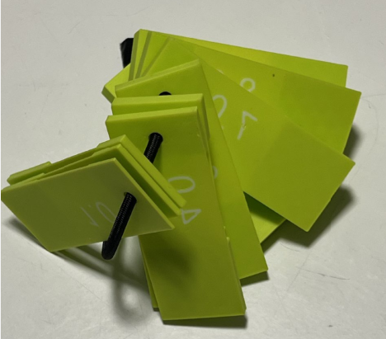 | 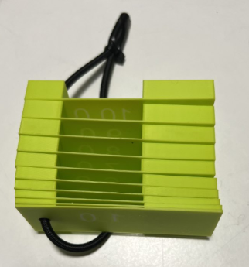

Project Goal
Create a set of plates with a fixed thickness to quick measure height.
The available thickness are:
- 1.0
- 2.0
- 3.0
- 4.0
- 5.0
- 6.0
- 7.0
- 8.0
- 9.0
- 10.0

Sketch
This a 80×30 mm rectangle, with a central part with a thickness of 0.6 mm so it can be flexible and 2 side towers with the nominal height.
The 5 mm hole is perfect for an elastic rope to keep all spacers toghether.
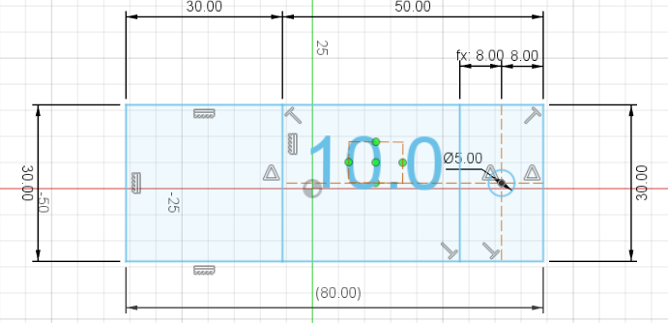

3D

Main 30x30 socket
This is the control surface where we apply the nominal height. In the example below it is 10 mm
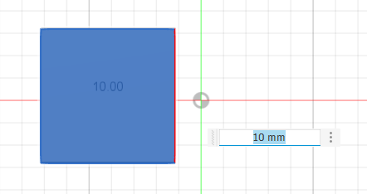

Central part
This is the flexible part
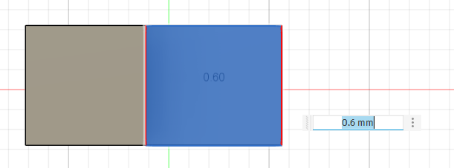

Ring Side
This surface extrusion is linked to the first block
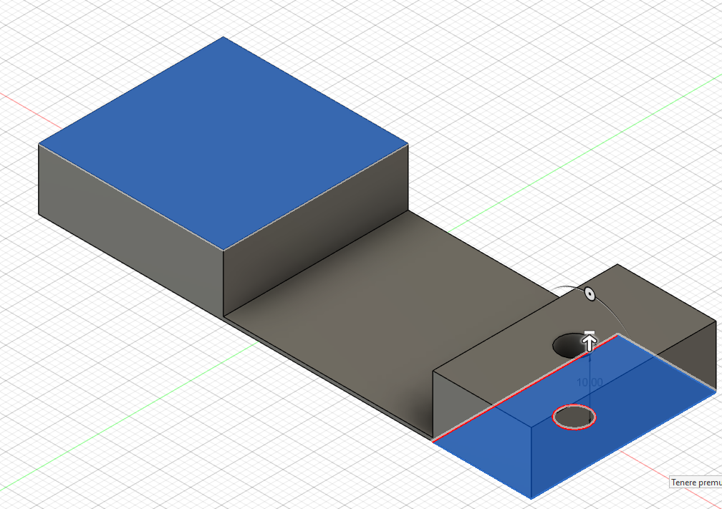

3D Layout
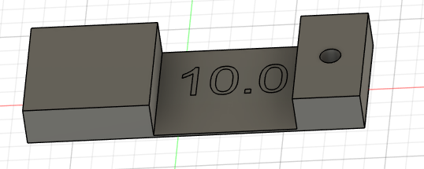

Print Layout
We need 2 colors, one for the body and one for the text
